SQLite Database Schema

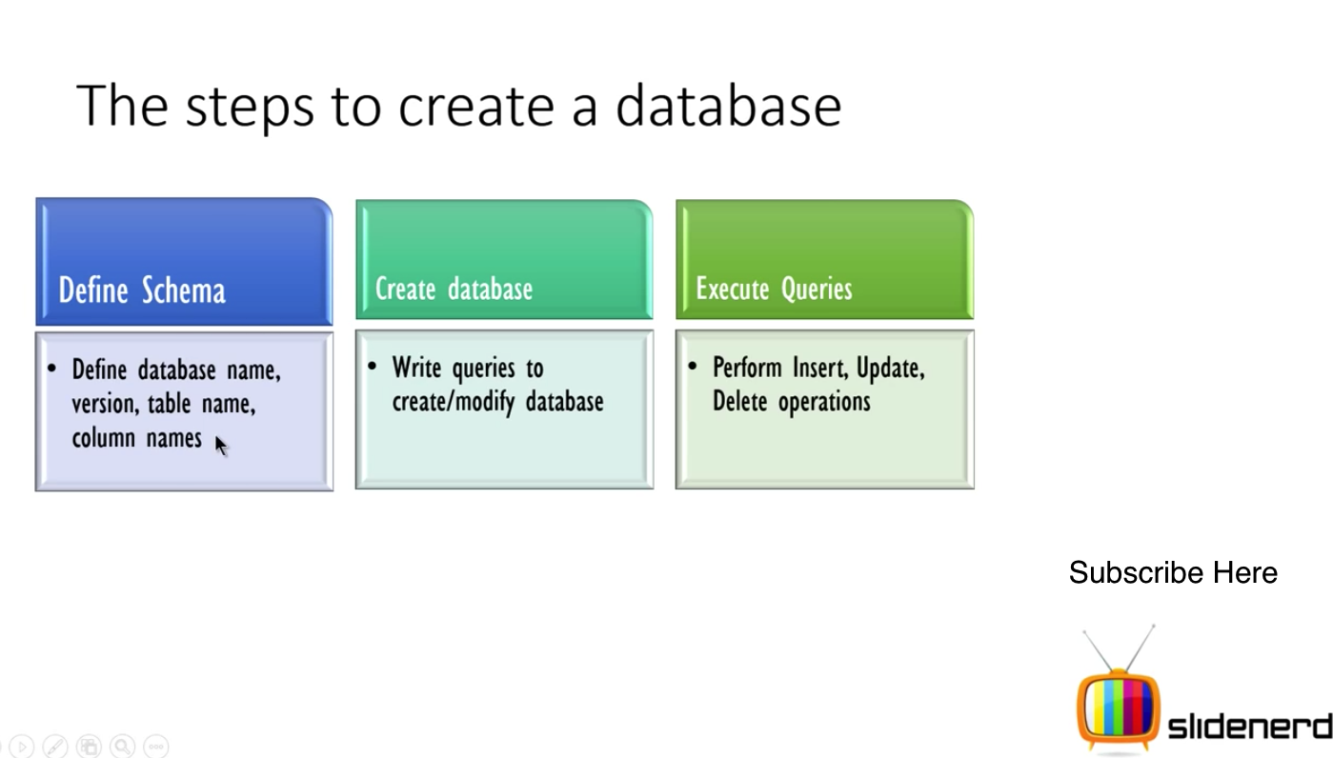

In Android, it is a common convention that primary keys start with underscore. i.e. “_id”.

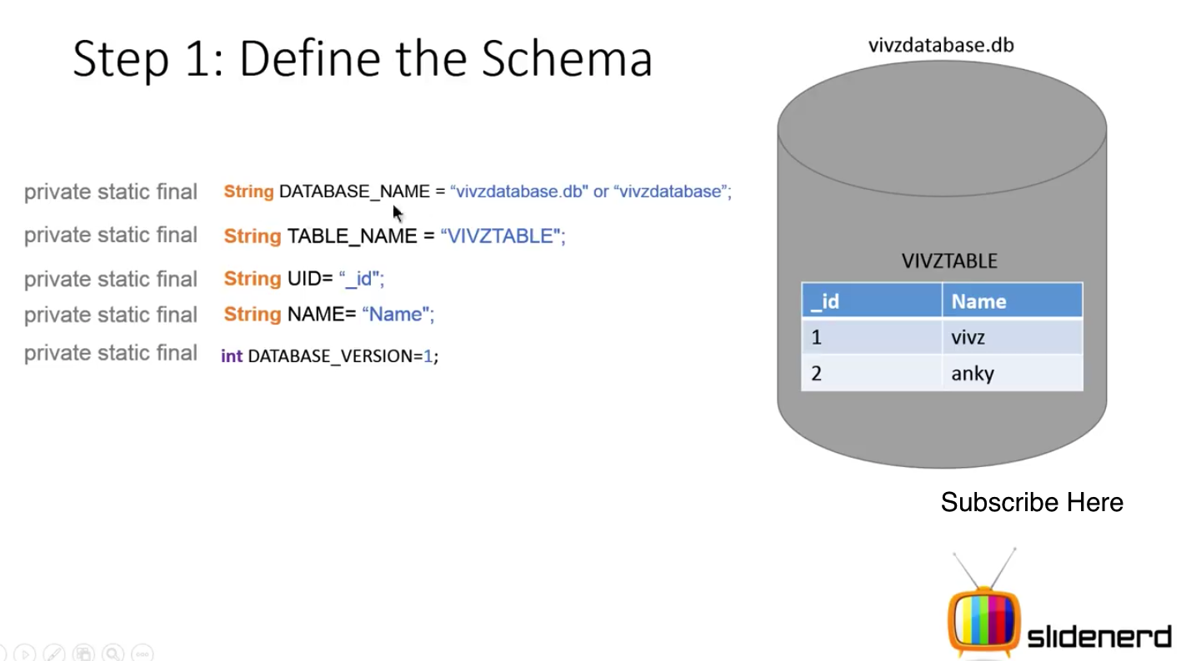

The SQLiteOpenHelper

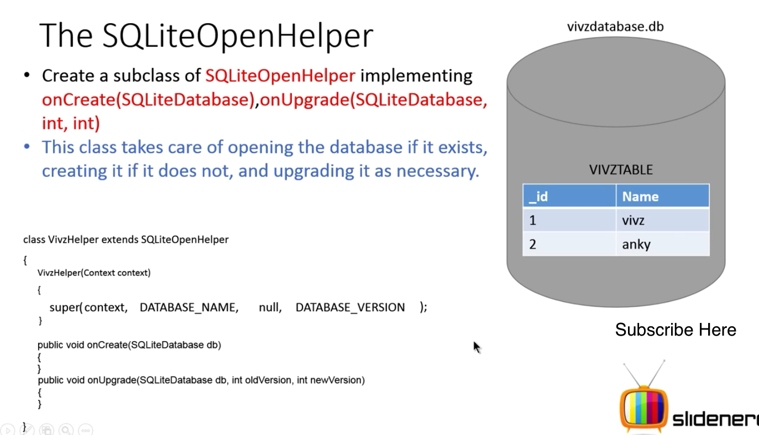

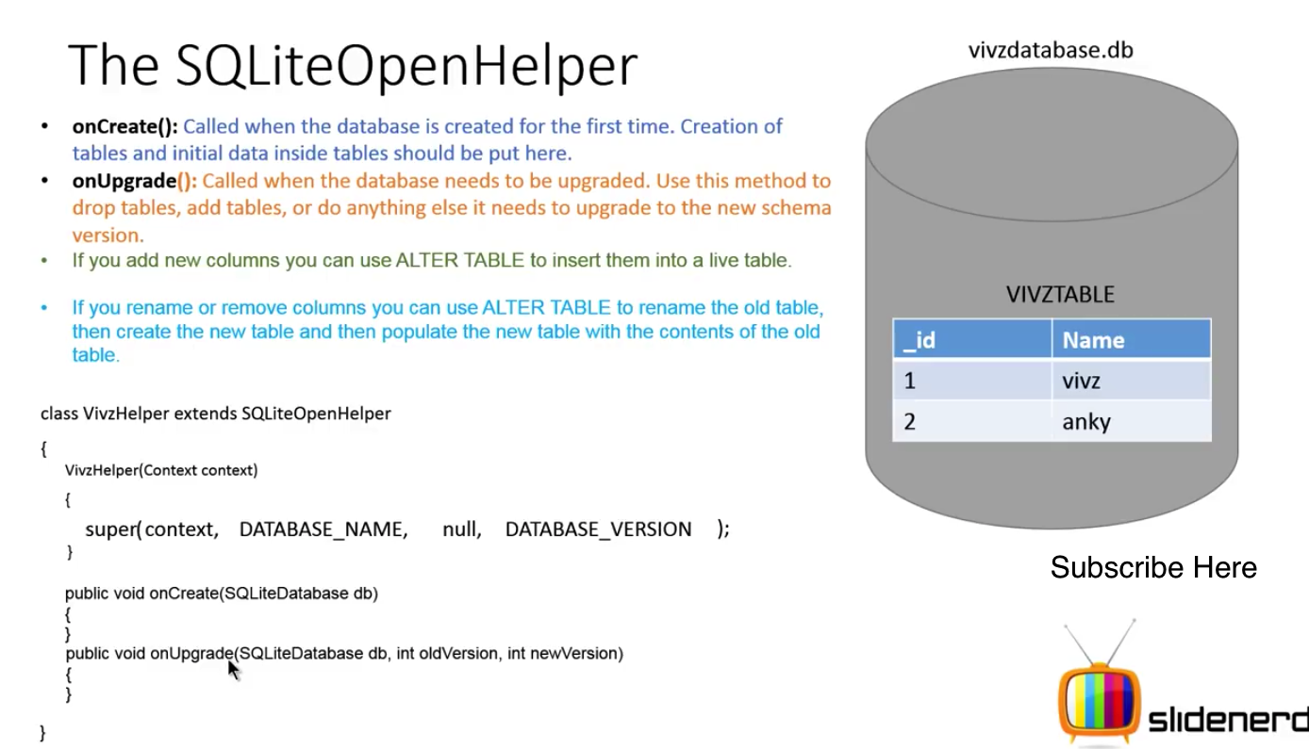

SQLite Database class

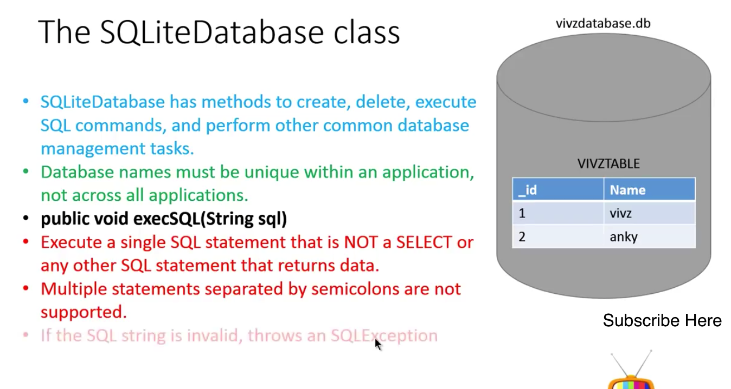

Step1:Implement the onCreate

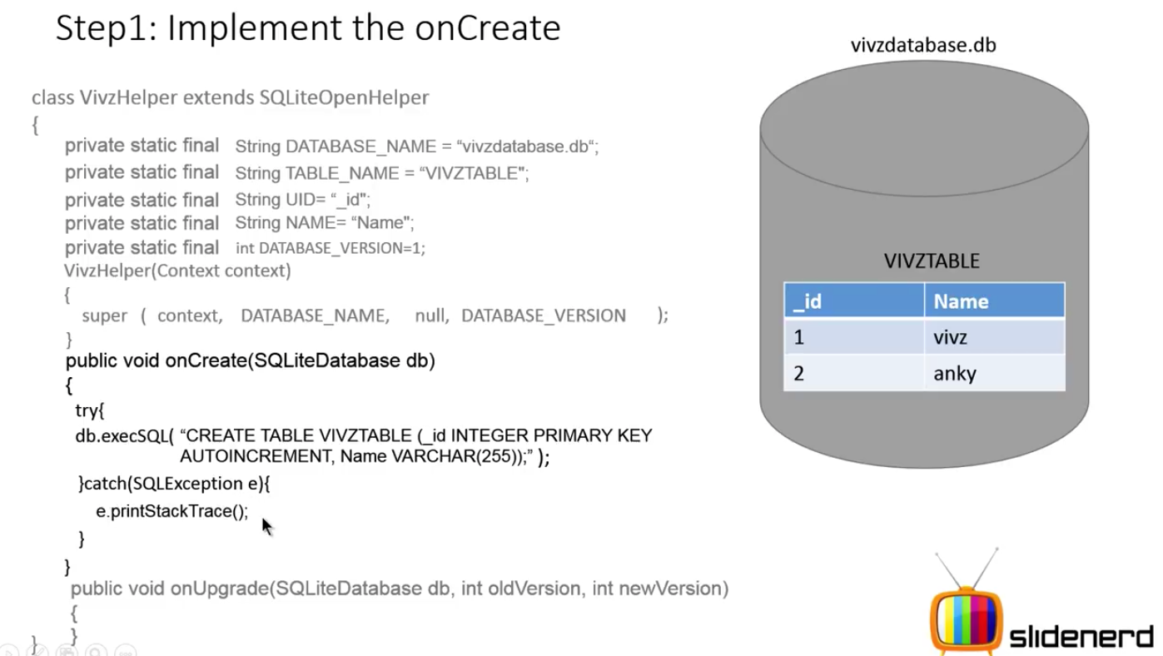

Step1: Implement the onUpgrade

Items on the update are flexible depending on what users want to do. Options includes drop table, save table content, add table.

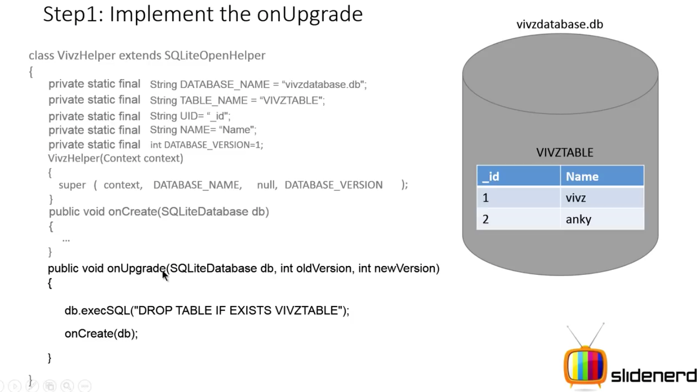

OnCreate is called again to recreate the table with the new statement that we added